CORRUGATED ESTIMATING FOAM LOGIC FOR 3D FOAM

Estimate Maintenance SPEC Screen

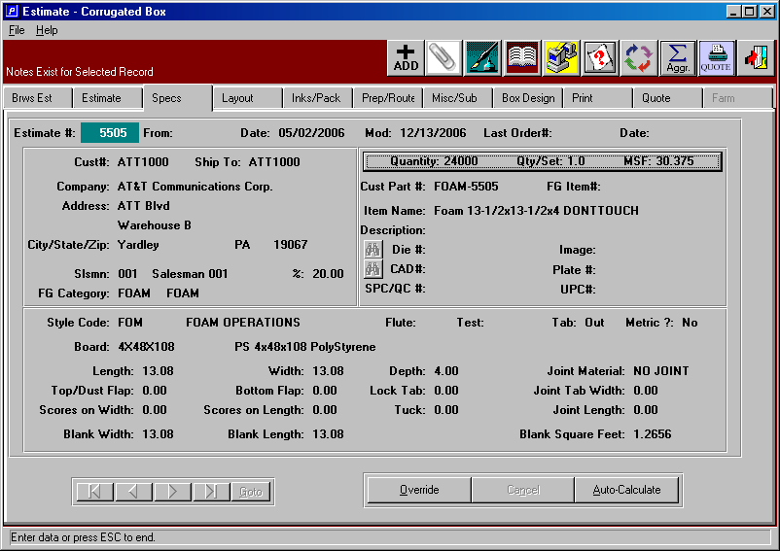

Estimating Foam Logic

Estimating foam evokes a new layout folder, which adds a depth dimension to the screen.
The depth dimension is added to the blank or finished product size, the die size, net sheet size and the gross sheet. When adding an estimate for foam or adding foam part to a set estimate, the style must be FOAM. Once the length, width and depth are entered, the layout size will automatically be calculated with one out and one up.
Estimate Maintenance Die / Sheet Layout Screen

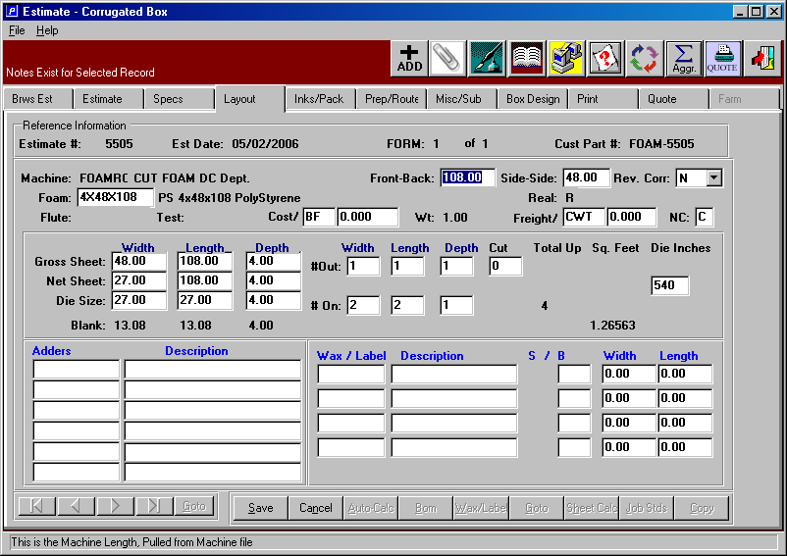

MOST EFFICIENT LAYOUT

The system will calculate the most efficient number out on a two dimensional plank of foam or a three dimensional bun. Foam may be cut from a bun into planks on a saw, slitter, hot wire machine or other machine that cuts the foam from a three dimensional size to a two dimensional size into a finished product or may be further cut on a die cutter into the finished size.

To cut a bun down into a plank or bun and then die cut, use the following procedure. First, enter the style foam and the finished product dimensions. Next, go to the Layout folder and press the Auto-Calculate button. Enter the die cutter machine code at the top of the screen, then press the TAB key. This will automatically calculate the maximum number up on the width and the length that will fit on the die cutter. You may lower the number up on either dimension and the system will recalculate the net sheet size. The system may recalculate the number out on the gross sheet size. Override this dimension to 1 x 1 for there is only one out.

BEST FIT LAYOUT

Press the SHEET CALC button, then enter the machine that will convert the foam such a band saw, convoluter saw or hot wire machine that will cut the bun or gross sheet into the net sheet size that will run through the die cutter. The program will prompt to enter three characters to sort for a specific foam material. If you want EPS foam, then enter EPS and press the ENTER key. A list of all the EPS foam will appear with the calculated number out. Please note, the program will only list foam material that start with the letters EPS in this example. Once you select a foam material from the list, the foam code, foam dimensions from the raw materials file and the number out on the width, length and depth will transfer to the estimate. You are finished. If you want to override any dimensions, you may press the OVERRIDE button to make a few changes. Please note, the stocked size to the foam cannot be change since this is an actual stocked material.

To calculate the most efficient cutting process without die cutting, then simply press the SHEET CALC button, enter the saw, convoluter saw or hot wire machine that will cut the bun or gross sheet into the net sheet size. Next, the program will then prompt to enter three characters you sort for the foam material. If you want EPS foam, then enter EPS and press the ENTER key. A list of all the EPS foam will appear with the calculated number out. Please note the program will only list foam material that start with the letter EPS. Once you select a foam material from the list, the foam code, foam dimensions from the raw materials file and the number out on the width, length and depth will transfer to the estimate. You are finished. If you want to override any dimensions, you may press the OVERRIDE button to make a few changes. Please note the stocked size to the foam cannot be change since this is an actual stocked material.

Estimate Maintenance Unitizing / Freight Screen

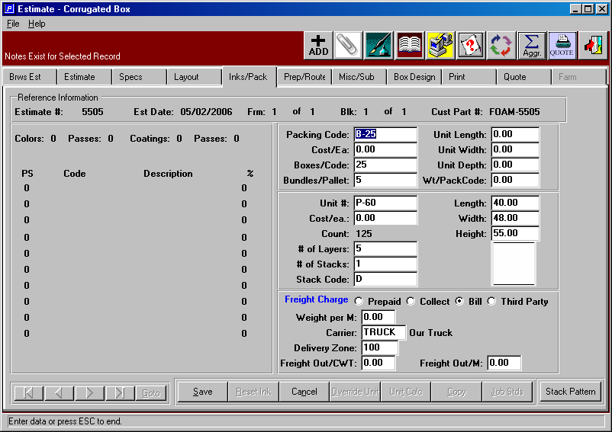

Estimate Maintenance MACHINE ROUTING Screen

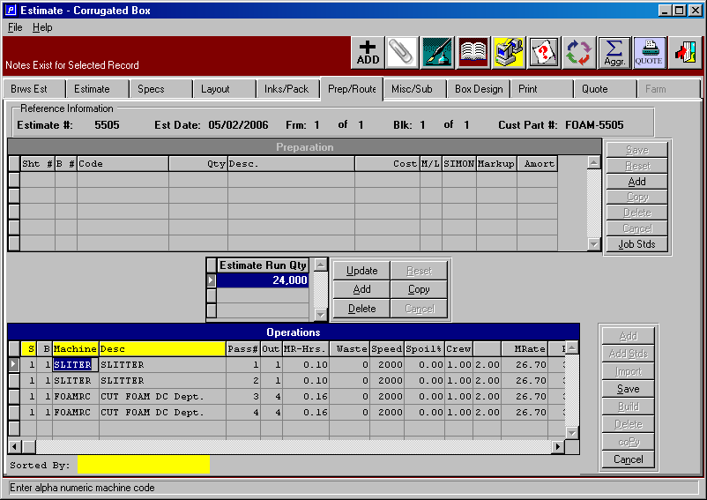

CORRUGATED ESTIMATING FOAM LOGIC FOR 3D FOAM

Estimating 2D and 3D foam :

Network Administration, system reference files must have the material type 1 defined as polyethylene, material type 2 defined as polyurethane, material type 3 defined as expanded polystyrene and material type 4 as polystyrene in the material types file.

Raw Materials File: All stocked Foam Material sheets and buns must be defined with a material type of 1, 2, 3 or 4. Also, the item name (know as the 1st description line) should be consistent for all similar foam types, since the lookup to find the material is dependent on the first three characters. For example start all expanded polystyrene as EPS 24x48x90 Yellow. When searching for EPS, the sheet calculation button in estimating only focus on EPS when the N-K-control field called SHTCALC logical value is YES, which dictates searching by the first three characters. This is the same logic for searching for stock board. All foam material must have the field called raw material stocked checked, thus defining each foam as real stocked material with actual width, length and depth dimensions. There is one exception, there must be a foam material called FOAM, which is estimated material only. The description is simply Foam. This will be used in the style file. Finally, all foam material must be prices per BF for board feet.

Style File: The style file type must be set to F for foam. The style file default board material should be set to a generic foam material such as FOAM.

